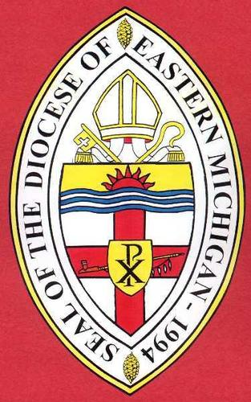
The Episcopal Diocese of Eastern Michigan
Pray + Learn + Serve + Grow

Trustees
Purpose: The Trustees have oversight of and make investment decisions concerning funds belonging to the Diocese of Eastern Michigan and also funds belonging to individual congregations of the diocese if the diocese and the individual congregations have asked them to do so. The principal of these trusts, if allowed by the particular trust, may be combined for the purpose of investment, in a single fund, and the income from such fund shall be paid over proportionately to the beneficiaries of the several trusts. The Trustees are also responsible for preparing a report for the Annual Convention each year, including in that report a statement of all sales, conveyances or mortgages of real estate made by them and all income, expenses, gains, and losses during the preceding year, and of the property held by them as Trustees.
Terms and Makeup: There are eight positions; two positions are elected each year by the Diocesan Convention to a four-year term.
Responsibilities: Members are expected to participate in regularly scheduled quarterly meetings or via teleconference. Meetings are tentatively scheduled for the April, July, October, and January after the close of the financial quarter. Members are also expected to review financial documents pertaining to quarterly investment performance prior to each meeting. These documents are currently distributed electronically via email in PDF format.
Skills and knowledge: Competency in email and word processing is necessary for communications work. Knowledge concepts and terms used in financial investing, such as stocks, bonds, mutual funds, asset allocation, peer group performance, large cap, midcap, small cap, growth stocks, etc, is highly desired.

