April 12, 2017

Brothers and Sisters in Christ,
With the announcement of Bishop Todd Ousley’s resignation, and as we begin to celebrate the past ten years of ministry with our bishop, the Standing Committee and I would like to offer a word about the transition.
The Diocese of Eastern Michigan is an innovative and resilient branch of the Jesus Movement. The ministry of the diocese and our great congregations continues without pause. We have a fine group of leaders on our Standing Committee and Diocesan Council, as well as the support of an outstanding diocesan staff. Our history is one of meeting challenges with creativity and flexibility and we will continue doing this over the next several months.
On June 30th, Bishop Ousley will officially resign his jurisdiction as bishop of the Diocese of Eastern Michigan. At that point, the Standing Committee will become the Ecclesiastical Authority. This shifts all authority and responsibility of the bishop to that canonical body, except those responsibilities reserved for a bishop such as ordinations and confirmation.
The Standing Committee and I are in contact with the Rt. Rev. Clay Matthews, Bishop for the Office of Pastoral Development of the Episcopal Church, who supports dioceses in transition. As we work to formalize the transition plan, we will keep you informed of developments through regular email communications as well as through the new Transition page of our diocesan website.
In addition, please save the date for a celebration of Bishop Ousley’s sixteen years of combined service as congregational developer and bishop, to take place the evening of June 4th, the Feast of Pentecost. We will let you know more about this soon.
We ask your prayers of support as we take on this important work.
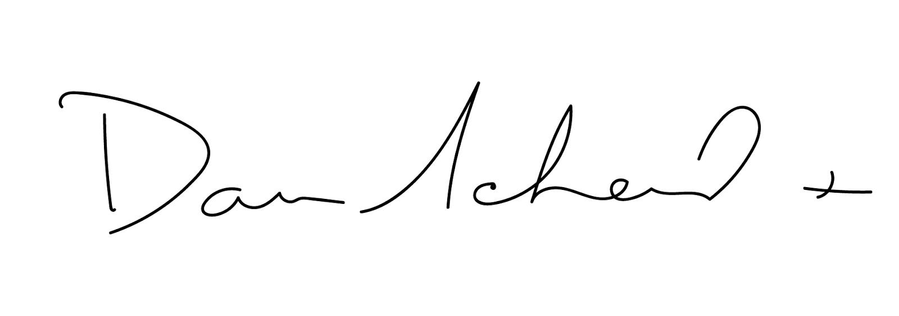
God’s blessings and peace,

The Rev. Daniel S. Scheid
President of the Standing Committee
The Episcopal Diocese of Eastern Michigan

